Finding good sources for your research project

- If you're going online to do research, you will probably be using Google

- Question: What makes a source of information “good”?
- Reliable, trustworthy, has authority
  - Government of Canada – YES!
  - Uncle Al's House of Knowledge – NO!
- Current – depending on your topic, you MAY want some older information, to show how the topic has developed over time; but that is the only good use for old information!
- Readable – unless you're a scientist, you should avoid scientist's papers!

- Reading a website address: www.climatechange.gc.ca

the topic is climate change
'gc' is Government of Canada
'.ca' is the DOMAIN name

- For your bibliography, open a blank document and copy/paste the web addresses of sites you use into it; save it on your desktop for later, e.g.,

www.climatechange.gc.ca/

https://en.wikipedia.org/wiki/Climate_change_in_Canada

http://www.davidsuzuki.org/issues/climate-change/science/impacts/impacts-of-climate-change/

- Google News will help you find the most up-to-the-minute news stories on your topic, from around the world – besides newspapers, it will list links to magazine articles and stories on TV news shows:

https://news.google.ca/news?pz=1&hl=en&tab=nn

- Use the Google search box’s AUTOFILL FEATURE to help you find subtopics for your assignment, e.g.

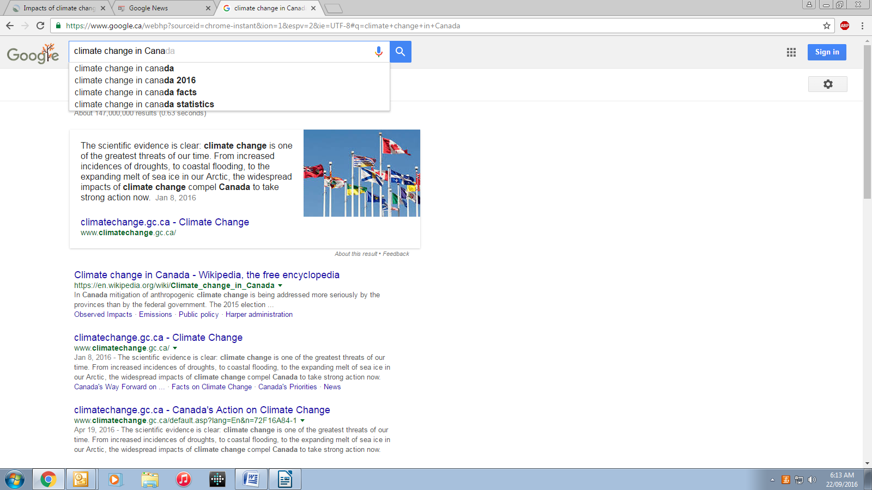

You may find it helpful to make a web of the suggestions that come up from using the autofill feature, for further research.

Having problems? Ask for help!

