INTRODUCTING THE NEW BAYSIDE BRANDED CLOTHING RANGE
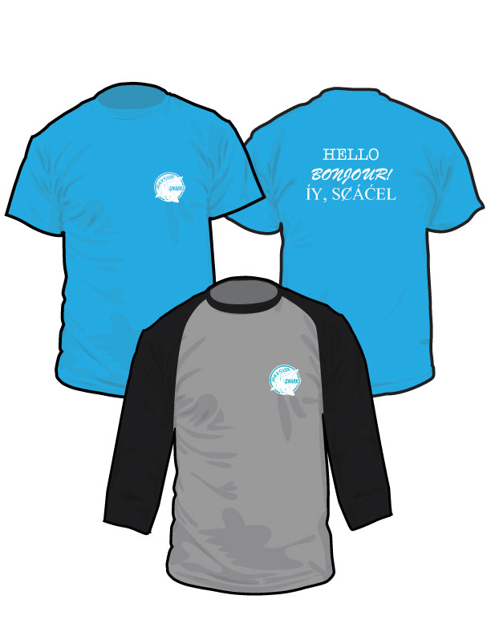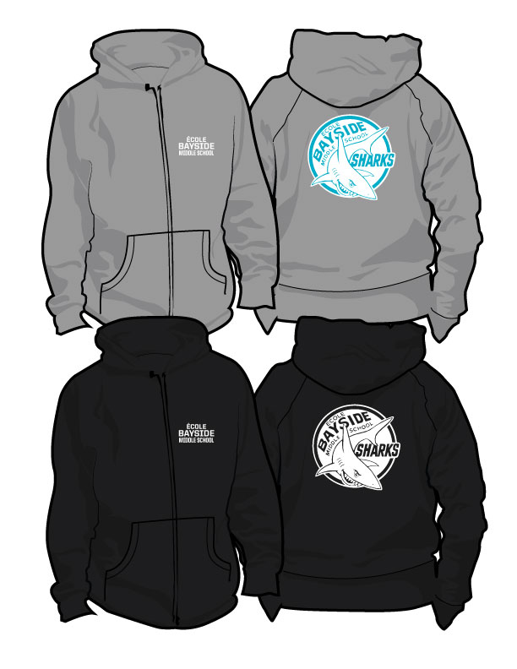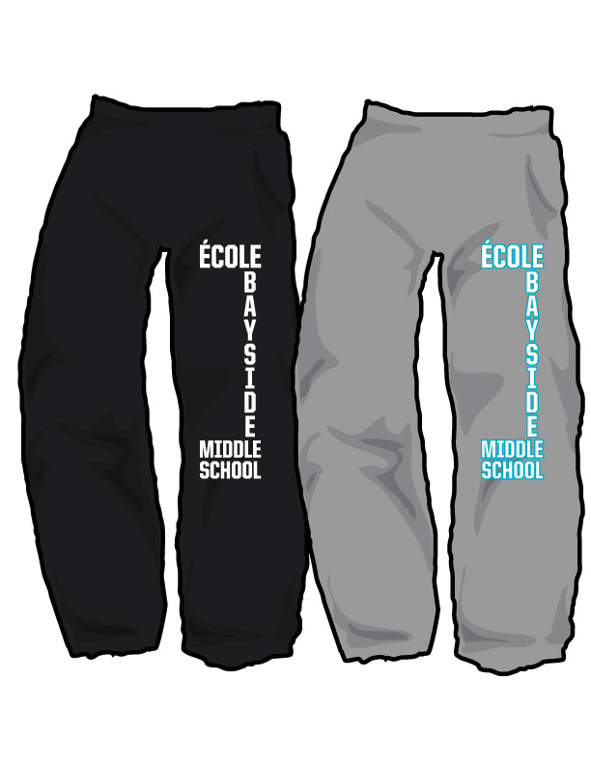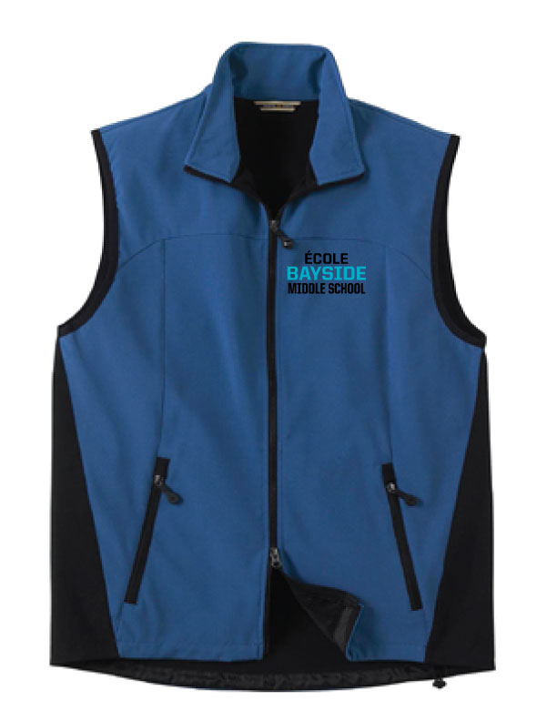
Product descriptions:
Gildan Saphire T-Shirt:  10-oz, 100% cotton preshrunk jersey knit  Adult Deep Heather/Black Baseball Tee:  52% combed and ring-spun cotton/48%  polyester, 40 single 5,7 oz./yd². Contrast  raglan sleeves, and neck trim. Side-seamed.  Unisex fit.  Youth White/Black Baseball Tee:  • 6.8-oz, 100% combed and ring spun cotton  • Ultra Soft 30 single jersey  • 1x1 rib knit collar  • 3/4 length contrast colour raglan sleeves  • Side seamed. | Russell Adult & Youth Hoodies:  - 50/50 cotton/polyester  - Dri-power® moisture management fabric  - Two-ply hood with grommets  - Contrast jersey shoulder tape  - Rib V at centre front  - Self material front and back side inserts  - Set-in sleeves  - Rib knit cuff and waistband  - Cover seamed neck, armholes and waistband | Russell Adult Sweat Pants:  - 50/50 cotton/polyester  - Dri-power® moisture management fabric  - Closed bottom  - No pocket  - Multi needle covered elastic waistband with draw cord  - Elastic hem bottoms  - Graded inseam  Russell Youth Sweat Pants:  - 50/50 cotton/polyester  - Dri-power® moisture management fabric  - Closed bottom  - Pocketed - side entry  - Multi needle covered elastic waistband  - Graded inseam | Men’s and Women’s Regata Blue Vest:  ▪ 8,000 mm waterproofness/800 g breathability, 7.4 oz./yd2/250 gsm  ▪ 4% spandex bonded with 100% polyester jersey  ▪ 96% polyester/4% spandex bonded with 100% polyester jersey  ▪ 3-layer performance stretch soft shell  Features:  ▪ inside pocket with audio port access  ▪ reverse coil zippered pockets  ▪ stretch binding finish on armholes adjustable shockcord at hem

